**Research Project Report**

**On**

**Analysis of number of hospitals and beds in India**

**with regards to the population**

Submitted by: Mansi

Roll no: 3569, New Delhi

**Objective of study:**

Considering the recent tragic outbreak of Covid-19 all over the world. Keeping in the mind the not so excellent medical facilities in India as compared to other super power countries like the USA or china, it is very crucial to optimize the available resources and put them to use in the proper way. It is vital to minimise the damage caused by the virus and save lives.

**About the data:**

The files contain the details of number of beds and hospitals in different states and union territories as of July 2018. The dataset is further classified into the ministries that maintain these hospitals and beds (Ministry of Defence, Railways etc.).

It includes:

1. Number of Primary Health Centres(PHCs), Community Health Centres(CHCs), Sub-District/Divisional Hospitals(SDHs), District Hospitals(DHs) and beds, India, State/UT wise as uploaded by the State/UTs on the Health Management Information System (HMIS) portal of the Ministry.
2. Number of Govt. Hospitals and beds in Rural and Urban Areas, India, State/UT wise, as available in the Publication National Health Profile 2018.
3. Number of AYUSH hospitals and beds State/UT-wise, as provided by the Ministry of AYUSH.
4. Number of Hospitals and beds maintained by Ministry of Defence, State wise and Total.
5. Number of Railway Hospitals and beds, as available in the Publication National Health Profile 2018.
6. Number of Employees State Insurance Corporation Hospitals and beds, State/UT and Total, as available in the Publication National Health Profile 2018.

**Latest scenario:**

With the latest reports as on May 2020, we have the list of top 5 worst hit cities in India on which emergent actions and control are needed. They are, namely,

Maharashtra,

Gujarat,

Tamil Nadu,

Delhi,

Rajasthan

With the collected dataset, the following observations can be obtained by various queries

1. Most populated cities in India

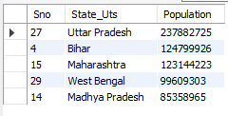

1. States/UTs with maximum number of hospitals

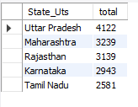

1. States/UTs with minimum number of hospitals

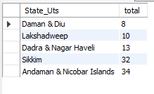

1. States/UTs with max number of beds

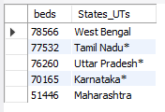

1. Sates/UTs with minimum number of beds

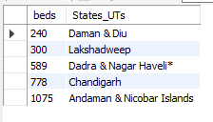

1. Number of beds in the state with max number of govt hospitals.



1. To look for zone wise distribution

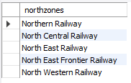

1. State/UTs with acute shortage of beds as of 2017



1. Share of hospitals by ministry of defence in the total number of hospitals

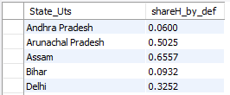

1. Number of beds per hospital

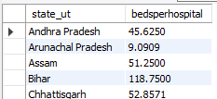

1. Number of hospitals per population shows us the availability of hospitals per capita.

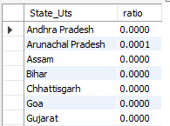

1. Number of beds per population gives the availability of beds per capita.

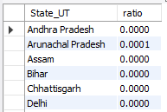

1. To know how back date data we are dealing with.

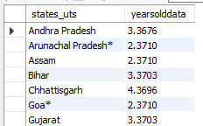

1. Status of states with regards to the number of beds available considering “fine” as above 2000, between 500 and 2000 as “poor” and below 500 as “critical”.

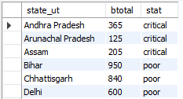

1. States/UTs with population more than 100000000 and total number of beds less than 1000 including beds from government, local and other hospitals.

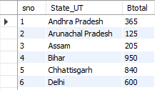

**Results and Conclusions:**

From the above observations, many useful things can be concluded. We have found how latest or recent is our data. The more recent the data, the more reliable it is to bring out conclusions. We have also found out the most and least heavily populated states/UTs. The most populated ones need the maximum attention and strict measures in the present scenario. The analysis on number of government hospitals has also provided us with the states/UTs the maximum and minimum number of hospitals and beds. Also, we have then categorised states/UTs as fine, poor and critical according to the number of hospitals and beds per capita. We could also analyse the share of defence ministries in the total number of hospitals in every state/UT. On analysing the given data for the number of beds in each hospital assuming equal distribution. Using these results, policies can be made in a better an efficient way. States with maximum number of Covid-19 cases should be under strict surveillance. By utilizing the results obtained from above, one can make better decisions as to how the number of beds have to be put to optimum use.

**References:**

<https://uidai.gov.in/images/state-wise-aadhaar-saturation.pdf>

<https://www.kaggle.com/dheerajmpai/hospitals-and-beds-in-india>

<https://www.pharmaceutical-technology.com/news/india-covid-19-coronavirus-updates-status-by-state/>